Screenshots / Results :
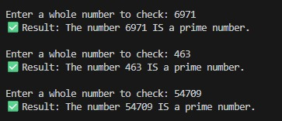
If the number is a prime

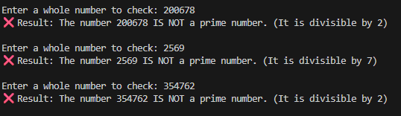
If the number is NOT a prime

